Write cache data to reuse data. It is usually used with Lookup transformations, to make it more efficient.

You may write data to a cache ( a .caw file) or keep data in memory. Cache data is stored in text, **not recommended for sensitive data.**

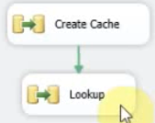

1. **First create the cache**

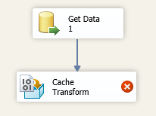

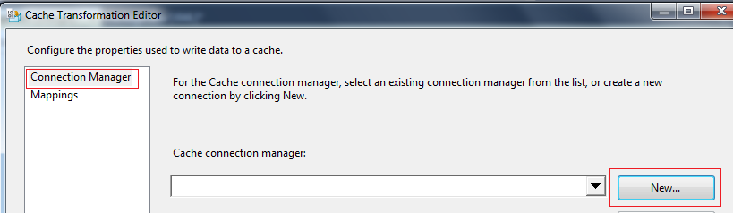

When clicking New:

Set Connection Manager Name to : MyCache

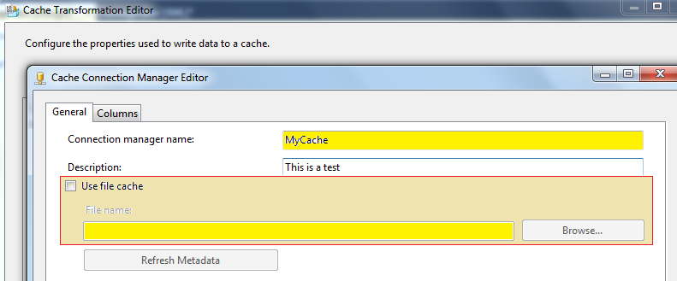

Important: If you will share the cache data in different projects, then check the CheckBox (Use File Cache) and then select a file where to store the data. If you will not reuse the data in different projects, don’t check the checkbox.

**IF YOU ARE GOING TO USE THE SAME CACHE DATA IN DIFFERENT PROJECTS, THEN STORE THE DATA IN A FILE, AT LEAST ONE TIME. OR RELOAD THE CACHE DATA WHEN IT CHANGES, IF IT IS STATIC KEEP A FILE.**

Now set the columns. Remember to set which fields are the index, when ‘0’ they are not part.

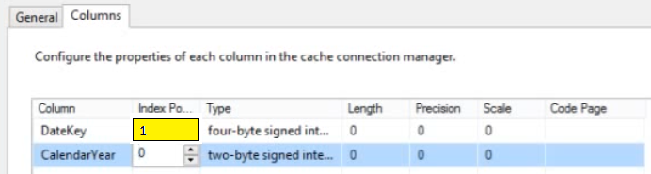

Set mapping

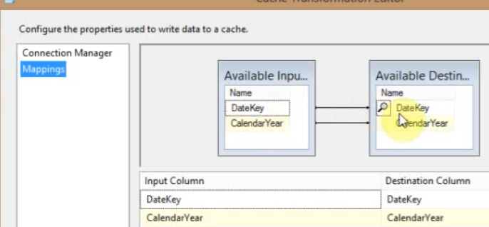

Now that the cache is made, then use it as lookup

1. **Make Lookup**

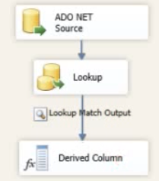

The lookup

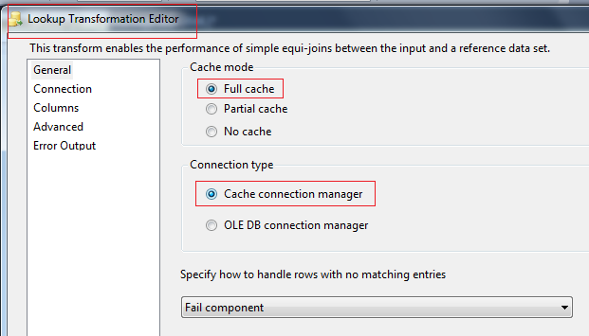

For the connection set the name as the one created previously: MyCache

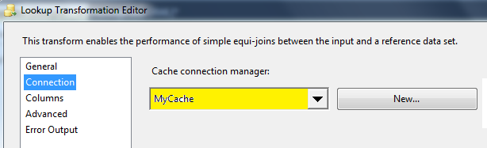

For Columns

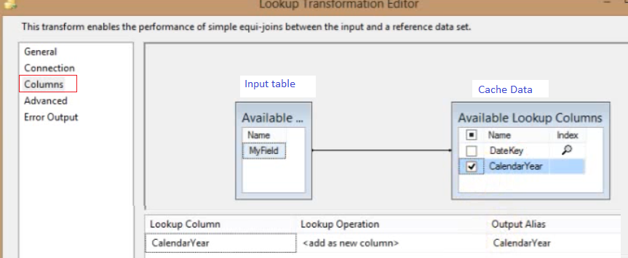

For the next control, Derived, set the output

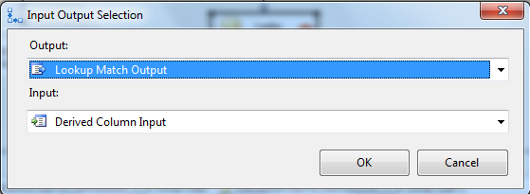

Enable Data Viewer

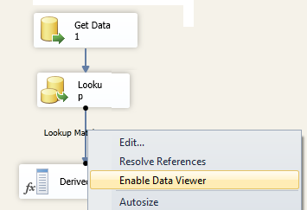

In the viewer we will see

* All the fields in the Input table
* All the fields checked in the lookup

|  |  |
| --- | --- |
| MyField | CalendarYear |
| 2005 | 2005 |
| 2001 | 2001 |
| 1999 | 1999 |

